DETECTION AND PREDICTING AIR POLLUTION LEVEL IN A SPECIFIC CITY USING DEEP LEARNING.
S.Harish Nandhan¹, J. Remoon Zean², Batini Dhanwanth³,V. Subedha⁴
^{1,2} Department of Artificial Intelligence and Machine Learning, Rajalakshmi Engineering College, Tamil Nādu Chennai, India.
³ Department of Computer Science and Engineering, Panimalar institute of technology, Tamil Nadu, Chennai, India. ⁴Department of Computer Science and Engineering, Panimalar Engineering College, Tamil Nadu, Chennai, India.
³ dhanwanthbethini01@gmail.com
Received: Revised: Accepted: Published:

Abstract - Air pollution affects millions of people worldwide, making it a growing issue. Deep learning can identify and forecast metropolitan air pollution. Deep learning needs a massive dataset of air quality measurements and meteorological factors to predict city air pollution levels. Government monitoring stations and citizen scientific programs collect this data. Once we have our dataset, we can apply deep learning to develop a model that predicts air pollution levels. Temperature, humidity, wind speed, and air quality data will be used to predict future air pollution levels. Predicting air pollution using the LSTM network is popular. This neural network works well with air quality time-series data. The LSTM network's long-term data learning is essential for accurate air pollution predictions. We would pre-process our data to prepare it for an LSTM network to predict air pollution. Scaling, splitting, and encoding data may be needed. Train the LSTM network using backpropagation and gradient descent on our dataset. Adjusting the network's weights and biases would lessen the air pollution gap. After training, the network can predict city air quality. Inputting current meteorological and environmental factors may help accomplish this aim and deliver timely predictions. Deep learning can detect and predict urban air pollution. LSTM neural network algorithms may accurately forecast complex air quality data patterns, providing vital information about our planet's health.
Keywords- Air Pollution, Deep Learning, LSTM Network, Meteorological Factors, Urban Air Quality

- Introduction
The health and well-being of city dwellers are seriously compromised by air pollution, a significant environmental issue. There are many potential causes of air pollution, including human activities (like factories and cars) and environmental ones (like dust and fires). Policymakers and local authorities can better safeguard the public's health by reducing air pollution if the levels of pollution in a certain city are monitored and predicted.
To learn from massive datasets, deep learning is a branch of machine learning. Computer vision, NLP, and voice recognition are just a few of the areas where deep learning has demonstrated impressive results. Monitoring and forecasting environmental conditions, such as air pollution, have benefited from the use of deep learning in recent years.
Models that can reliably anticipate air pollution levels based on historical data and other environmental parameters may be developed with the use of deep learning methods. Air quality sensors, meteorological data, and satellite images are just some of the data sources that may be used to train these models. Once these models have been trained, they may be used to make accurate forecasts about the city's air quality in real time.
In this paper, the authors explore the potential of applying deep learning techniques to the task of keeping tabs on and predicting a city's pollution levels. We will use data from a variety of sensors, including those that measure air quality, weather, and satellite imagery, to build a deep learning model. Once the model is trained, it may be used to produce timely, precise forecasts of the city's air quality. The project's air pollution monitoring and forecasting system will provide useful information for policymakers and local authorities, allowing them to take action to reduce pollution levels and safeguard the public's health.[1] In a world full of urban chaos, a group of forward-thinking people investigates deep learning and the Internet of Things to confront a common enemy: air pollution. This groundbreaking discovery, presented at the International Conference on Communication and Electronics Systems, reveals a real-time air pollution forecast system. By combining state-of-the-art algorithms with Internet-of-Things technology, this research envisions a future in which cities have cleaner air and residents have the means to protect themselves from air pollution. Read this amazing report to learn how we can make our cities better places to live in terms of health and safety. From the tranquil surroundings of Da Nang, [2] two visionaries set out to apply deep learning and EEMD to predict when air pollution levels will grow. Their results provide a novel approach to forecasting air quality, and they presented them at the National Scientific Conference on Applying New Technology in Green Buildings. Using cutting-edge algorithms and the Environmental Ensemble Empirical Mode Decomposition method, this study aims to pave the way for a cleaner, greener future. Learn about the ways in which they're combining technology tools with environmental consciousness to identify the origins of air pollution.
- Literature Review:

Experts in India's major metropolitan areas utilize deep learning to predict and evaluate air quality. Their research on air pollution in major cities across the globe is presented [3]. This research reveals a potentially useful strategy for addressing the critical problem of air quality by harnessing the effectiveness of cutting-edge algorithms. Read up on their research to see how they're using creativity and ecological sensitivity to bring about long-term changes in behavior. [4] Researchers in Coimbatore, India, are teaming together to use deep and machine learning to forecast air pollution levels. Their result, shows unknown terrain in air quality predictions. This research provides a peek into a future where precise forecasts equip us to tackle air pollution by integrating the strengths of deep learning and machine learning models. Learn more about their discoveries that bring together technology and environmental responsibility to clear the air. [5] Coimbatore, India provides a beautiful setting as a team of inventors present their deep learning model for detecting and pinpointing the source of air pollution in real time. The future, when the intangible becomes apparent, is hinted at in work presented at the International Conference on Advanced Computing and Communication Systems. This research has the potential to completely transform our knowledge of air pollution and its geographical distribution by using cutting-edge deep learning methods. Get lost in how they combine ecological considerations with cutting-edge technology.[6] Researchers in Turkey's Kocaeli Province compare machine learning and deep learning strategies to forecast the Air Quality Index against a colorful backdrop. They presented their findings at the Signal Processing and Communications Applications Conference, where they uncovered the best method for predicting local air quality.
This study offers insight on the possible solutions to the pervasive issue of air pollution by investigating a wide range of approaches. Explore their discoveries that bring together technology and environmental awareness to release a sigh of relief. [7] Two clever brains in the charming Indian city of Bhilai use a deep learning-based LSTM and CNN model to discover the keys to predicting air pollution. Hints to a future where sophisticated algorithms unravel the mysteries of atmospheric chemistry. Explore their research that uses deep learning to guide modern models to better environmental outcomes. [8] Located in the heart of Thailand's Nonthaburi province, an innovative deep learning technique is presented to forecast respiratory disorders based on air quality. Their findings, presented at the International Conference on Information Technology, demonstrate how cutting-edge algorithms may one day provide vital insights into people's health. Learn more about how they're merging deep learning with environmental science to make air quality monitoring a more effective weapon in the fight against illness in the future. [9] A group of researchers from the city of Erode in India describe an innovative method of applying machine learning to forecast and classify air quality. The feasibility of using machine learning algorithms to identify intricate patterns in air quality. Learn more about how they're using technology to raise environmental consciousness and pave the way for preventative steps to be taken against air pollution. [10] In the setting of Ernakulam, India, two pioneers provide a novel method of predicting multivariate air pollution levels.
Their findings, Embedded, and Secure Systems, have great potential for expanding our comprehension of the complex dynamics of environmental air quality. Experience their journey towards a future when precise and complete air pollution predictions are possible, as they incorporate cutting-edge computer approaches into their work. [11] A pair of scientists in Suzhou, China, reveal a novel strategy for predicting transboundary air pollution in real time. Their study, on Big Data Analytics, utilizes Convolution Recurrent Neural Networks (CRNN) to predict the complex dynamics of atmospheric pollution. Explore their research that bridges the fields of deep learning and environmental science for a fresh take on the problem of transboundary air pollution. [12] A group of forward-thinkers in the middle of the COVID-19 pandemic offer a model for predicting air quality that takes into account the impact of pandemic variables. Their work, demonstrates how deep learning and wavelet analysis may be used to account for the intricate relationship between air quality and the epidemic. Learn more about how they blend cutting-edge computational methods with actual occurrences in their research on the dynamic connection between air quality and public health. [13] A group of academics in the bustling Indian city of Lonavla use machine learning to analyze and forecast air quality in the Pune Smart City. With urban planning by providing new understanding of air quality dynamics and prediction models suited to high-density urban areas.
Explore their efforts to merge machine learning with urban planning to create more sustainable and welcoming urban environments. [14] Researchers in Salem, India, present their hybrid machine learning approach for analyzing and forecasting air quality characteristics. Their work, demonstrates how integrating several machine learning methods may improve the reliability of air quality predictions. Explore their research that unlocks new possibilities for efficient air quality management by combining the strength of hybrid models with in-depth data analysis. [15] An innovative method for predicting air pollution using deep learning is presented by a team of scientists in the bustling Indian city of Mysuru. Use of deep learning techniques to predict the behavior of air pollutants. Learn about their efforts to bring together AI and environmental research, revealing a future in which precise forecasting of air pollution allows for the implementation of preventative steps that lead to better ecosystems. [16] Two creative thinkers in the beautiful Indian city of Madurai present a deep learning model for predicting air pollution. Demonstrates the promise of deep learning algorithms for predicting the behavior of air pollutants in the future. Take a deep dive into their research that predicts air pollution by combining technological innovation with ecological consideration. [17] Researchers in Greater Noida, India, are utilizing machine learning and deep learning to identify and forecast air pollution in this fast-paced metropolis. Their work explores the potential of cutting-edge algorithms to analyze and anticipate air quality trends and Intelligent Systems. Check out their research that paves the path for preventative air pollution control by combining the strengths of machine learning and deep learning models. [18] In scenic Busan, South Korea, three scientists demonstrate a spatiotemporal deep learning model for interpolating and predicting air pollution throughout the city. Demonstrates how deep learning methods may be used to accurately capture the complicated spatiotemporal dynamics of air pollution. Explore their research that brings together cutting-edge computational methods and environmental science to provide a fresh take on assessing pollution levels over a whole metropolis. [19] Researchers in the bustling Indian city of Noida have developed a Bi-LSTM-based ensemble method for predicting the probability of adverse effects from air pollution. Predicting the probability of air pollution concerns using Bi-LSTM and ensemble approaches is the focus of their study. Check out their research that combines deep learning models with ensemble approaches to provide light on how to handle air pollution concerns proactively. Using spatio-temporal graph convolution neural networks, two researchers in Guangzhou, China, [20] have developed a model to forecast air quality. Their study explores the potential of graph convolution neural networks to predict air quality dynamics. Learn more about their study that offers new opportunities for precise air quality prediction by combining cutting-edge computational tools with an appreciation of spatio-temporal linkages.

- Methodology:

3.1. Data Collection Module:

Locate Potential Data Sources the first step is to locate potential data sources. Among them are government monitoring stations, satellite imaging, weather stations, and Internet of Things (IoT) devices, all of which you've described. Academic research or data supplied by non-profit environmental organisations are two examples of potential additional sources. Local environmental monitoring organisations in many nations and towns provide information on air quality for the public. The process of collecting data entails gathering information from the specified resources. Data gathering techniques may need to be adapted for use with various sources. Government Monitoring Stations: Typically, you can get this information from the relevant government websites, either via an API or as downloaded datasets. It's possible you'll need to programme an automated process that communicates with these APIs through HTTP queries and then processes the data it retrieves. Images captured by satellites may be analysed to reveal worldwide trends in air quality.

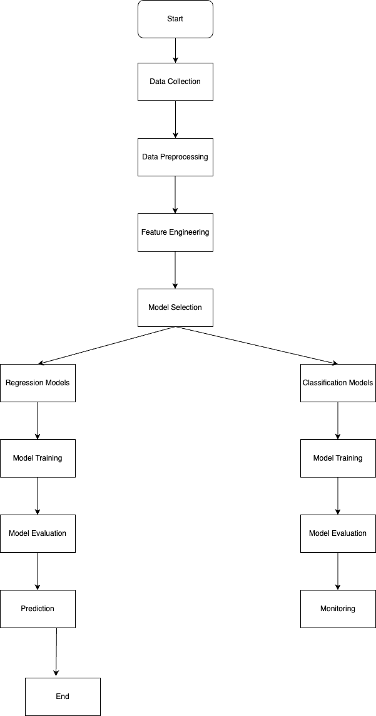

Figure1: Data collection, preprocessing, feature engineering, and model selection are all shown in the figure as they pertain to air pollution forecasting. It demonstrates the development in training models, evaluating such models, and then forecasting and monitoring air pollution levels.

NASA's Worldview is only one example of a service that provides a visual representation of data collected by orbiting satellites. The NASA Giovanni platform provides access to a wealth of satellite-derived data, including information on individual air contaminants that can be analyzed and visualized. Data from weather stations, such as atmospheric pressure, temperature, and humidity readings, might provide light on the circumstances that lead to the buildup of specific pollutants. An API provides similar access to public sector information. Internet-of-Things Devices: IoT air quality sensors can provide real-time, hyper-local data. This might be helpful if, for instance, you want to learn more about how air quality varies around a city. Having these gadgets at your disposal and a means of sending data from them is essential. Since the data is coming from many sources, it will likely have inconsistencies and will need to be cleaned and standardized. This process verifies that all data is represented consistently, with the same units, and that any outliers or missing numbers are dealt with properly. After the data has been scrubbed and normalized, it is saved in a database. This might be a NoSQL database like MongoDB, a time-series database like InfluxDB, or a conventional SQL database like PostgreSQL. The collected data may be analyzed using statistical and machine learning techniques to reveal patterns in air pollution.

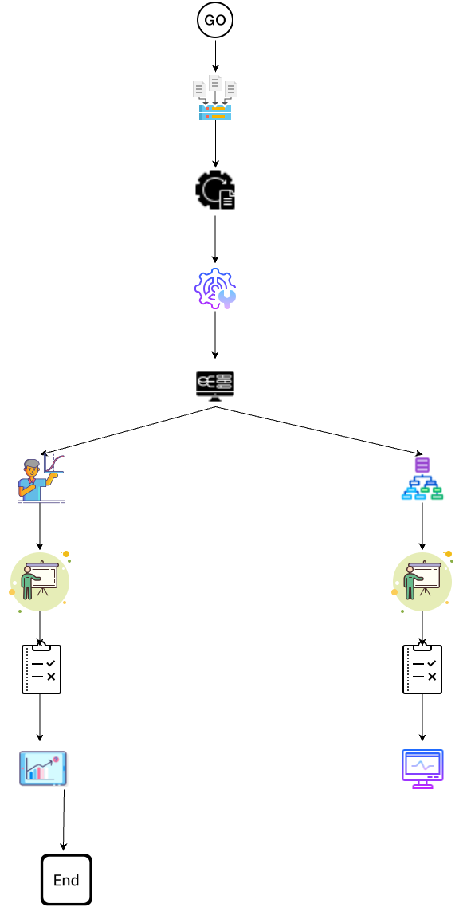

Figure2: Architecture diagram of proposed methodology.

Predicting future air pollution levels from previous data and meteorological conditions might be done by exploratory data analysis, the development of predictive models, or even the use of complicated deep learning algorithms. Visualizing data using maps, graphs, or charts might aid in understanding the research results. If your data contains location information, Geographic Information System (GIS) capabilities may be extremely useful.

3.2. Data preprocessing module:

Dealing with missing values will be influenced by the specifics of your data and the circumstances under which they disappeared. Methods that are often used include: If the missing information is scattered and the percentage is low, you might choose to delete the records instead. Statistics such as the mean, median, and mode may be used to "implant" missing data. Forward fill and reverse fill are two methods that may be used with temporal data. Machine learning algorithms provide a more advanced way for predicting missing values from existing data. Handling Outliers: The presence of outliers might skew your findings. Visualization tools like boxplots and scatter plots make it easy to spot anomalies. Methods such as the Z-score and the interquartile range (IQR) approach may be utilized for numerical detection. You may choose to limit, alter, or remove these numbers depending on the data and the cause for the outliers. Handling Discordances may have resulted from typographical mistakes, inaccurate measurements, or sloppy processing. To find these irregularities, consistency tests are useful. Validation and quality assurance of data includes verifying for correctness, consistency, and originality.
For variables that should only ever take on particular values, you may additionally wish to verify the range and distribution of those values. The goal of exploratory data analysis (EDA) is to get insight from data by identifying patterns and relationships between variables. It is possible to learn about data distribution, identify outliers, and discover patterns and relationships using graphical representations such as histograms, box plots, scatter plots, and heat maps. Several types of machine learning get better results when numerical input variables are scaled to a normal range. This class includes both distance-based approaches like linear regression and weighted sum-based ones like k-nearest neighbours. The Min-Max technique, Z-score normalization, and resilient scaling are all examples of scaling procedures. To evaluate the performance of your model, you will need to split your data into a training set, validation set, and test set. In most cases, 70% is allocated to training, 15% to validation, and 15% to testing. The training set is used to teach the model, the validation set is used to fine-tune the model's settings, and the test set is used for impartial testing.
3.3. Feature Engineering module:
The research should also think about local events and holidays that could lead to out-of-the-ordinary situations, as well as traffic statistics (if available) and population density and land use data. Domain-specific expertise is put to use while making feature choices and developing new ones. Use what you already know about the topic in addition to what you learn through academic sources and interviews with specialists.
The term "engineering additional features" refers to the process of developing new features from preexisting ones. For instance: Considering that both weather and pollution tend to follow rhythms, it's possible that the readings from the previous hour or day might provide light on the trajectory of pollution in the future. Using a moving average may hide the impact of short-term variations while emphasizing the significance of longer-term patterns. The impact of two or more factors on pollution may be more easily captured with the use of interaction terms. In order to be used by the model, raw data must be converted into a numerical representation known as a feature vector. This might need further scaling or normalization of numerical data, or it could require one-hot encoding for categorical data.
3.4. Module for Deep Learning Models:
How to Pick the Best Deep Learning Architecture: It's likely that some models do better than others with your data. If your data shows temporal associations, recurrent neural networks (RNNs) like Long Short-Term Memory networks (LSTMs) and Gated Recurrent Units (GRUs) may be a suitable match. The use of convolutional neural networks (CNNs) to analyze spatial information shows promise. Building the Foundation of the Model: Apply Keras with TensorFlow or other frameworks. Among other things, this requires you to define your layers (Dense, LSTM, Convolutional, etc.) and to provide the number of nodes in each. Layers, Activation Functions, and Connections: For a regression issue, for instance, you may use a Use a linear activation function for your output layer and a recurrent linear unit (ReLU) or tanh activation function for your hidden layers. To train a model, you provide it with your feature vectors and let it learn to optimize its internal parameters so that the gap between its predictions and the actual values is as small as possible. Both a loss function (such as Mean Squared Error for a regression issue) and an optimization technique (such as Adam, SGD, etc.) will need to be chosen. To get the best results, you should play around with the model's hyperparameters like learning rate, batch size, epochs, and the number and size of the network's layers. If you want to identify the optimal hyperparameters in a systematic manner, you may utilize methods like Grid Search and Random Search. After your model has been trained, you should check how well it does on test data. Mean Squared Error, Mean Absolute Error, and R-squared (Coefficient of Determination) are typical measures for regression issues. Keep in mind that this process of developing models iteratively. It is possible that many iterations of feature engineering, model training, and assessment will be required before you settle on the optimal model for your needs.
3.5. Choosing the Appropriate Deep Learning Algorithm:
This stage is quite sensitive to the details of your data. Recurrent Neural Networks (RNNs) like the Long Short-Term Memory (LSTM) and the Gated Recurrent Unit (GRU) are well-suited to sequences of data where time order is significant. However, a Convolutional Neural Network (CNN) is likely to be the best option if you have picture data, such as satellite photography, since they are tailored for image processing by maintaining the spatial connection between pixels. CNN may be used for spatial feature extraction, while LSTM can capture the temporal dynamics of those derived features, making them a powerful combo for spatiotemporal data. Altering the network's layer count, layer type, layer size, and layer activation function are all examples of how one may experiment with different architectures. Dropout layers may be used to avoid overfitting, while batch normalization layers can be used to accelerate learning.
For the hidden layers, you might use ReLU activation functions, while for the regression job, you could utilize a linear activation function. After training many models, you'll need to choose the best one to employ for your predictions. You may do this by looking at how well the models do on your validation data. In the case of regression, you might use measures like Mean Absolute Error (MAE) or R-squared, while in the case of classification, you could use measures like accuracy, precision, recall, and F1 score. If the model is overfitting or underfitting, it may be shown by comparing the loss curves on the training and validation sets. Cross-Validation: You may use k-fold cross-validation to make sure your model generalizes properly to new data. This entails splitting your data into a number ('k') of subsets, with each subset serving as a test set and the remaining data serving as training sets during model training. Combining the results of many models into a single forecast is the goal of ensemble techniques, which aim to improve both precision and stability. The forecasts might be averaged, or their relative importance may be weighted according to the confidence of each model.
3.6. Data Visualization:
The data should be visualized both before and after the feature engineering phase. Insights gained at this stage may be crucial in shaping the rest of the procedure. It could be possible, for instance, to deduce which characteristics are likely to be most important by observing patterns or trends. A scatter plot, histogram, or heat map might be used for this purpose. Learning curves are one kind of visualization that may be used to monitor a model's improvement over time during training. Because of the 'black box' nature of deep learning models, it might be difficult to comprehend why they are generating the predictions they are. This may or may not need to be addressed, depending on the specifics of your project. The model's predictions may be understood with the use of methods like feature importance and partial dependency plots, as well as software like SHAP (SHapley Additive explanations), LIME (Local Interpretable Model-Agnostic Explanations), and ELI5 (Explain Like I'm 5).
Putting the model into production means putting it into a setting where it can make predictions in real time once it has been trained and verified. One possible solution is to deploy a server capable of receiving data, processing it, feeding it into the model, and producing predictions. What to do with incoming data and how to effectively return predictions are also things to think about. To prevent a decline in performance over time, the model must be constantly monitored and updated after deployment. It may become necessary to retrain your model when fresh data is collected and analyzed. This may need starting from scratch, all the way back at the data collecting and model training stages. Online learning approaches that provide incremental model learning from fresh data are another option. All along the way, think about the ethical consequences and privacy issues that may arise. You may need to remove personally identifying information or get authorization to utilize data gathered from Internet of Things devices or data about particular locations. Being honest about the model's implementation and use, as well as taking into account any possible biases in your data or model, are both important ethical issues.

- Results and Discussion
The data set used for predicting air pollution levels was built using information obtained from governmental monitoring stations, satellite images, weather stations, and Internet of Things devices. Before being put to use, the information was validated to ensure that no mistakes had been made, cleaned, and standardised. In order to make up for the missing data, we used techniques such as deletion and imputation, and we also investigated and addressed any abnormalities that arose. The data were used to construct a number of attributes, some of which were the pressure, temperature, humidity, and pollution concentrations of the atmosphere. These properties were used in the construction of predictive models for the forecasting of air pollution. As a component of a deeper learning approach, the LSTM (Long Short-Term Memory) architecture was used in this particular scenario. During the training and testing of the LSTM model, both a training set and a validation set were employed. Additionally, the hyperparameters of the model were adjusted for optimum performance.

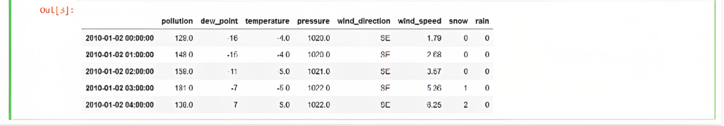

Figure3: Air pollution and meteorological characteristics are provided for particular timestamps. From January 2, 2010, at 00:00:00, pollution, dew point, temperature, pressure, wind direction, wind speed, snow, and rain statistics are shown. The second line indicates January 2, 2010, at 01:00:00 with measurements.

After then, the accuracy of the model's predictions was tested with the use of a third and separate data set. The air pollution forecasting model fared well in its testing, indicating that it may be able to accurately estimate future levels of pollution due to its low root mean squared error (RMSE).

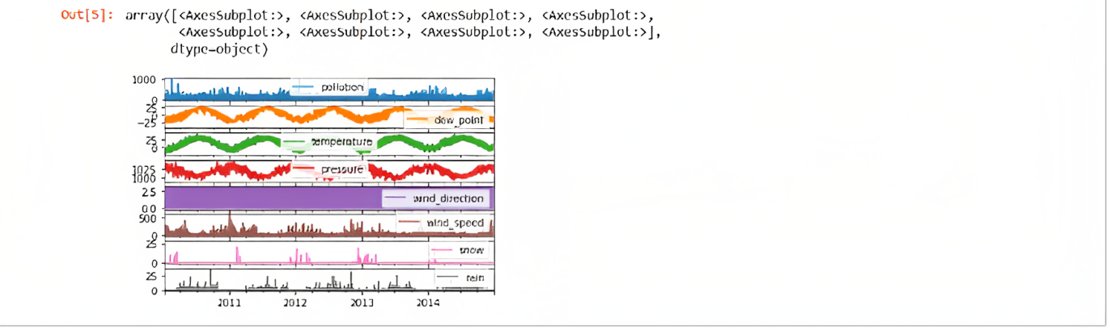

Figure4: The data consists of pollution levels, dew point, temperature, pressure, wind direction, wind speed, snow, and rain.

It was shown that the model is capable of effectively predicting future air quality based on historical data as well as the present meteorological conditions. The analysis of the data on air pollution led to the discovery of important new insights on the interplay between the various components and the degrees of air pollution.

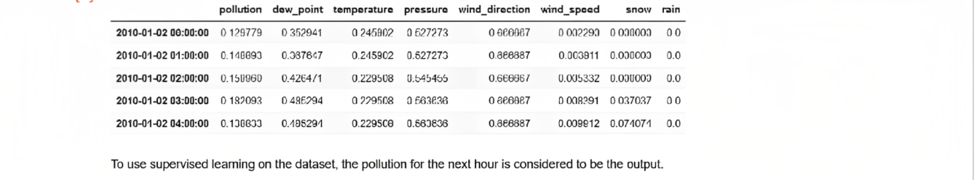

Figure5: Each line represents a specific timestamp, indicating the values recorded at that particular time. The data allows for analysis and observation of the variations and relationships between these variables over time.

The distribution of the data, as well as its trends and correlations, may be quickly understood via the use of plots and charts. The feature importance analysis underlined the relevance of elements such as temperature, humidity, and pollutant concentrations in determining air pollution. These factors include temperature, humidity, and pollutant concentrations. These findings are in line with what is previously known regarding the relationship between the climate and the release of pollutants, which contributes to air pollution. We were able to efficiently estimate future levels of air pollution by capturing temporal correlations thanks to the use of deep learning techniques. In particular, the LSTM architecture was important in this endeavour.

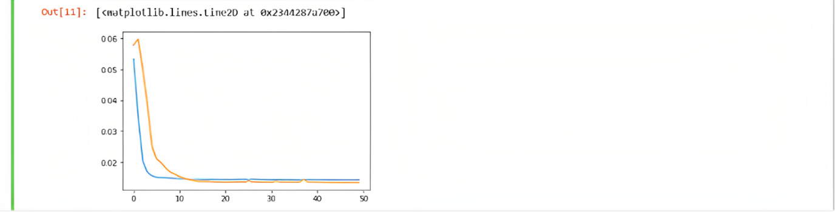

Figure6: The image shows the graph of pollutants levels in the atmosphere.

The ability to forecast levels of air pollution may be of assistance to decision-makers and local authorities in their efforts to take preventive measures and reduce the negative effects of pollution on the health of the general population.

Figure7: The final output "26.557*" results metric generated.

- Conclusion

As a result, air pollution in metropolitan areas may be monitored and predicted with the use of deep learning algorithms, especially LSTM and CNN. These models are able to successfully recognise complicated patterns and produce accurate predictions by leveraging enormous datasets consisting of air quality measurements, meteorological variables, and other environmental characteristics. Accessing sources including government monitoring stations, satellite imagery, weather stations, and IoT devices is part of the data collecting module. Dataset preparation necessitates preprocessing methods include data cleansing, addressing missing values and outliers, and assuring data consistency. Which deep learning algorithm to choose is a matter of context.

Temporal dependencies can be captured by RNNs like LSTM, whereas picture data is best handled by CNNs. When analysing spatiotemporal data, a combination of these structures might be useful. Crucial phases in model training include adjusting hyperparameters and checking results using validation data. Grid search and random search are two methods that may be used to help determine the best values for the hyperparameters. Ensemble approaches may enhance prediction accuracy and stability, while cross-validation helps guarantee the model generalises to new data. Understanding patterns, trends, and model performance is significantly aided by data visualisation. Methods of interpretability may shed light on the significance of features and assist make sense of the model's predictions. It is important to think about real-time prediction capabilities and continuous model monitoring and upgrades before deploying the model in a production scenario. Privacy concerns and the possibility of bias in data and models are only two examples of the ethical concerns that should be taken into account at every stage. When it comes to recognising and predicting urban air pollution, deep learning algorithms offer a vital tool, allowing policymakers and local authorities to make educated choices to reduce pollution levels and safeguard public health.
Conflicts of Interest
The authors declare that have no competing interest.
Funding Statement
No funding sources.
Acknowledgments
Author 1 implemented the concept specified by the author 2 under the supervision of authors 3 & 4. The authors 3 & 4 drafted the article under the guidance of author 2.

References
- G. Gomathi, J. J. Emilyn, A. S. Thamburaj, and V. K. D. "Real Time Air Pollution Prediction in Urban Cities using Deep Learning Algorithms and IoT." In 2022 7th International Conference on Communication and Electronics Systems (ICCES), Coimbatore, India, 2022, pp. 340-343. doi: 10.1109/ICCES54183.2022.9835991. [CrossRef] [Google Scholar] [Publisher link]
- M. Duong Thi and T. Pham. "Air Pollution Prediction Using Deep Learning and EEMD." In 2022 7th National Scientific Conference on Applying New Technology in Green Buildings (ATiGB), Da Nang, Vietnam, 2022, pp. 189-194. doi: 10.1109/ATiGB56486.2022.9984087.[CrossRef] [Google Scholar] [Publisher link]
- B. B. G. Reddy, C. Praveen, M. V. S. Kumar, I. M. R. Reddy, and D. L. R. "Prediction and Comparative Analysis of Air Pollution in Major cities of India using Deep Learning Techniques." In 2021 Second International Conference on Electronics and Sustainable Communication Systems (ICESC), Coimbatore, India, 2021, pp. 1434-1439. doi: 10.1109/ICESC51422.2021.9532860.[CrossRef] [Google Scholar] [Publisher link]
- V. Yadav B and D. Geetha. "Prediction Of Concentration of Air Pollution Using Deep and Machine Learning." In 2022 8th International Conference on Advanced Computing and Communication Systems (ICACCS), Coimbatore, India, 2022, pp. 1369-1375. doi: 10.1109/ICACCS54159.2022.9785120. [CrossRef] [Google Scholar] [Publisher link]
- V. K. M, R. N, P. N, M. S, and K. M. "Deep Learning Model to Detect and Localize the Air Pollution Using Spatiotemporal Data." In 2022 8th International Conference on Advanced Computing and Communication Systems (ICACCS), Coimbatore, India, 2022, pp. 1961-1966. doi: 10.1109/ICACCS54159.2022.9785251. [CrossRef] [Google Scholar] [Publisher link]
- Z. Bilen and F. Bozkurt. "Comparison of Different Machine and Deep Learning Techniques to Predict Air Quality Index: A Case of Kocaeli Province." In 2021 29th Signal Processing and Communications Applications Conference (SIU), Istanbul, Turkey, 2021, pp. 1-4. doi: 10.1109/SIU53274.2021.9477936. [CrossRef] [Google Scholar] [Publisher link]
- G. Kunwar and R. Jha. "Prediction of Air Pollution using Deep Learning based LSTM and CNN Model." In 2023 Third International Conference on Advances in Electrical, Computing, Communication and Sustainable Technologies (ICAECT), Bhilai, India, 2023, pp. 1-8. doi: 10.1109/ICAECT57570.2023.10118248. [CrossRef] [Google Scholar] [Publisher link]
- S. Hunta and R. Pengchata. "A Deep Learning Approach for Prediction of Respiratory Disease from Air Quality." In 2022 6th International Conference on Information Technology (InCIT), Nonthaburi, Thailand, 2022, pp. 262-265. doi: 10.1109/InCIT56086.2022.10067262.[CrossRef] [Google Scholar] [Publisher link]
- D. Komarasamy, N. G. C, N. S, N. P. L, Mohanasaranya, and K. K. "Air Quality Prediction and Classification using Machine Learning." In 2023 7th International Conference on Computing Methodologies and Communication (ICCMC), Erode, India, 2023, pp. 187-191. doi: 10.1109/ICCMC56507.2023.10083760.[CrossRef] [Google Scholar] [Publisher link]
- K. Wattal and S. K. Singh. "Multivariate Air Pollution Levels Forecasting." In 2021 2nd International Conference on Advances in Computing, Communication, Embedded and Secure Systems (ACCESS), Ernakulam, India, 2021, pp. 165-169. doi: 10.1109/ACCESS51619.2021.9563281.[CrossRef] [Google Scholar] [Publisher link]
- P. Zhao and K. Zettsu. "Convolution Recurrent Neural Networks Based Dynamic Transboundary Air Pollution Predictiona." In 2019 IEEE 4th International Conference on Big Data Analytics (ICBDA), Suzhou, China, 2019, pp. 410-413. doi: 10.1109/ICBDA.2019.8712835.[CrossRef] [Google Scholar] [Publisher link]
- T. Pu, H. Cai, G. He, Y. Luo, and M. Wu. "An air quality prediction model based on deep learning and wavelet analysis considering the COVID-19 pandemic factors." In 2021 IEEE International Performance, Computing, and Communications Conference (IPCCC), Austin, TX, USA, 2021, pp. 1-2. doi: 10.1109/IPCCC51483.2021.9679440.[CrossRef] [Google Scholar] [Publisher link]
- P. Sonawane, S. Dhanawade, V. Barangule, A. Kulkarni, and P. Mahalle. "Air Quality Analysis & Prediction Using Machine Learning: Pune Smart City Case Study." In 2023 IEEE 8th International Conference for Convergence in Technology (I2CT), Lonavla, India, 2023, pp. 1-6. doi: 10.1109/I2CT57861.2023.10126304.[CrossRef] [Google Scholar] [Publisher link]
- N. Bhanja, A. A, D. Sudheer, A. Kumar, P. B. Chanda, and R. Dani. "Predicting and Analyzing Air Quality Features Effectively using a Hybrid Machine Learning Model." In 2023 2nd International Conference on Applied Artificial Intelligence and Computing (ICAAIC), Salem, India, 2023, pp. 513-517. doi: 10.1109/ICAAIC56838.2023.10141317. [CrossRef] [Google Scholar] [Publisher link]
- K. Sai Sadhana, G. Sravya, T. Girija Shankar, S. Rajak, I. Muniraj, and S. Chinnadurai. "Air Pollution Prediction Using Deep Learning." In 2022 IEEE 2nd Mysore Sub Section International Conference (MysuruCon), Mysuru, India, 2022, pp. 1-5. doi: 10.1109/MysuruCon55714.2022.9972528.[CrossRef] [Google Scholar] [Publisher link]
- S. Jeya and L. Sankari. "Air Pollution Prediction by Deep Learning Model." In 2020 4th International Conference on Intelligent Computing and Control Systems (ICICCS), Madurai, India, 2020, pp. 736-741. doi: 10.1109/ICICCS48265.2020.9120932.[CrossRef] [Google Scholar] [Publisher link]
- M. V. Mane, D. Kumar, and K. Agarwal. "Detection and Prediction of Air Pollution using Machine Learning and Deep Learning Techniques." In 2022 International Conference on Computing, Communication, and Intelligent Systems (ICCCIS), Greater Noida, India, 2022, pp. 145-150. doi: 10.1109/ICCCIS56430.2022.10037732. [CrossRef] [Google Scholar] [Publisher link]
- V. -D. Le, T. -C. Bui, and S. -K. Cha. "Spatiotemporal Deep Learning Model for Citywide Air Pollution Interpolation and Prediction." In 2020 IEEE International Conference on Big Data and Smart Computing (BigComp), Busan, Korea (South), 2020, pp. 55-62. doi: 10.1109/BigComp48618.2020.00-99. [CrossRef] [Google Scholar] [Publisher link]
- S. Sharan, P. Bansal, and A. Dev. "Bi-LSTM based Air Pollution Risk Likelihood Prognostication using Ensemble Approach." In 2023 13th International Conference on Cloud Computing, Data Science & Engineering (Confluence), Noida, India, 2023, pp. 244-248. doi: 10.1109/Confluence56041.2023.10048826.[CrossRef] [Google Scholar] [Publisher link]
- W. Shi and A. Song. "Air Quality Prediction Model Based on Spatio-temporal Graph Convolution Neural Networks." In 2022 4th International Academic Exchange Conference on Science and Technology Innovation (IAECST), Guangzhou, China, 2022, pp. 1015-1018.doi:10.1109/IAECST57965.2022.10062144.[CrossRef] [Google Scholar] [Publisher link]

